1. Prepare Culture Medium
1.1 Solute the following components in 1 L distilled water:
Proteose Peptone No. 3 10.0 g
Beef Extract 10.0 g
Yeast Extract 5.0 g
D-Glucose 20.0 g
Polysorbate 80 1.0 g
Ammonium Citrate 2.0 g
Sodium Acetate 5.0 g
Magnesium Sulfate 0.1 g
Manganese Sulfate 0.05 g
Dipotassium Phosphate 2.0 g
pH = 5.5 ± 0.2 at 25°C
1.2 Autoclave the culture medium at 121 °C for 20 minutes.
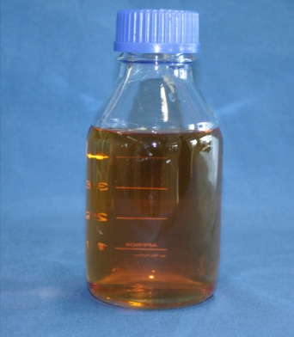

2. Prepare Over Night Culture
2.1 Inoculate 200 mL of the culture medium with Lactobacillus delbrueckii or L. plantarum.
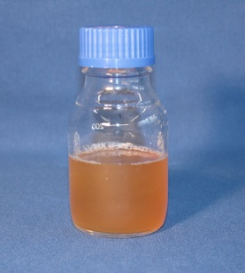
2.2 Incubate culture at 37 °C over night until there is a visible turbidity.

3. Prepare Fermentation
3.1 The fermentation is carried out under the following conditions:
- 37 °C e.g. in a water bath
- stirring at 100 rpm
- pH-controlled in the range of 5.0 – 6.0
3.2 Inoculate fermenter medium with overnight culture in relationship 10 : 1.
Task 1:
Take a probe and measure at t₀ optical density at 600 nm, lactic acid- and glucose concentration at 340 nm.
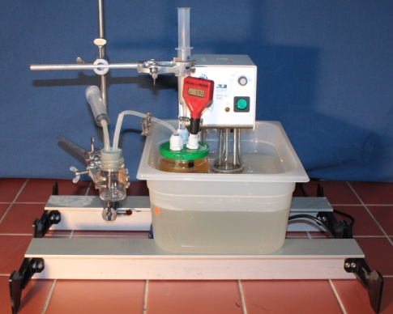

4. Fermentation
4.1 Ferment for 3 days at 37 °C and a pH of approx. 5.5.
For neutralization of produced lactic acid
add 2 M NaOH.
Task 2:
Take a probe each 2 hours out of the fermenter and measure optical density, glucose- and lactic acid concentration
during fermentation.
If glucose is consumed, feed medium with
a glucose solution of 180 g/L so that glucose concentration is 10 g/L.

