2. Separation of bacteria by centrifugation

2.1 Fill two times 40 mL of fermen-tation medium in two 50 mL Falcon-tubes.
2.2 Centrifuge both Falcon-tubes at 5000 rpm for 10 minutes.

supernatant
Überstand

pellet
Pellet

Left tube: after centrifugation

3. Lactic acid concentration by distillation

3.1 75 mL of supernatant will be distilled (Lactic acid: 122 °C).
3.2 Distille app. 50 mL H₂O.
3.3 Cool down the lactic acid solution.

4. Polymerization of lactic acid

4.1 Materials for polymerization:

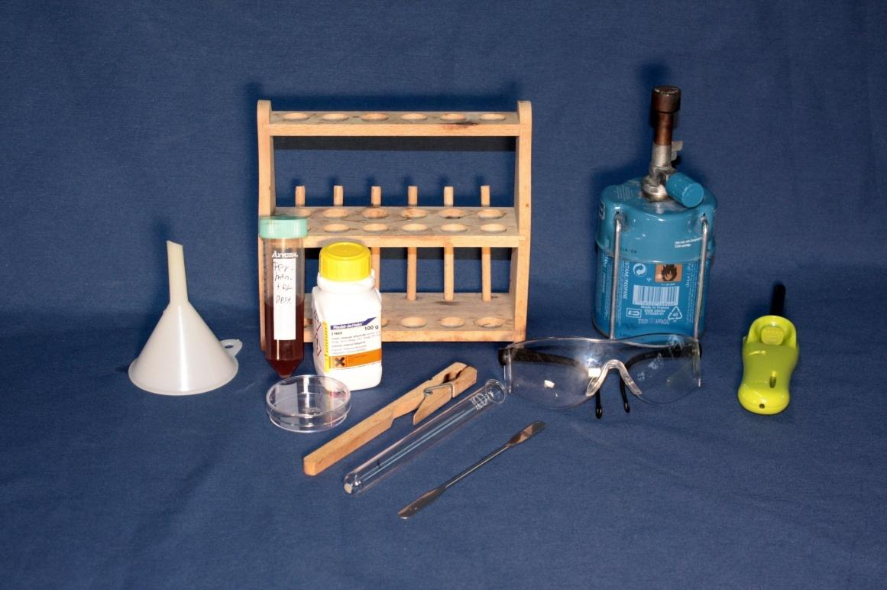
Test tube rack
Funnel
Petri dish
Test glass holder
Test glass
SnCl₂
Burner
Lighter
Probe
Protection goggles
Spatula

4.2 Pipette 5 mL of lactate solution in
a test glass.
4.3 Add in a test glass a little of the catalyzer SnCl₂.
4.4 Heat the solution for 5 to 10 minutes under the fume cupboard by steady shaking to avoid boiling retardation.
4.5 When the mass is boiling under an intensive white smoke production, pour the polymerizing mass in a 40 mL beaker.

By cooling down in the beaker PLA gets solid.

5. PLA-Degradation by Hydrolysis

5.1 Add 10 mL distilled water into the beaker and stirr.

PLA slowly gets soluble.

