Function of the fuel cell
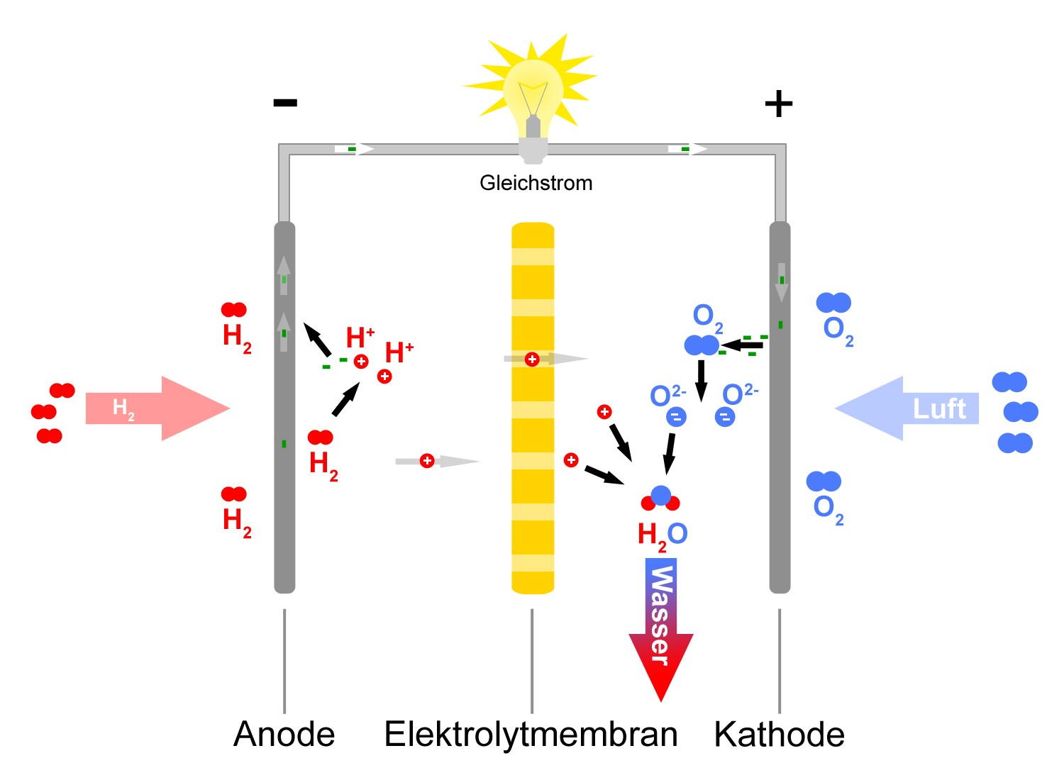
Direct-current ennnnnnnnnnnnnnnnnnnntentnt
cathode
Solid polymer fuel cell
anode

The hydrogen oxidized in the fuel cell, which means that the electrons are delivered.
Platinum acts as catalyst. The developed electrons diffuse from the minus-pole to the plus-pole, tensions arise, by which a power source can be run.
Protons, which developed during this oxidation, diffuse through the electrolyte-membrane.

At the plus-pole oxygen is reduced, so the O₂ molecule receives the electrons, which give off the hydrogen-molecule.
The oxygen can´t get diffused through the membrane.
But protons are able to percolate the membrane which causes electron flow.

The concentration gradient between the negative loaded oxygen atom and the positive loaded hydrogen atom strives for balance.

The O²⁻ Ion react with the H⁺ proton to water.

